**Line graph:**

The line graph below shows changes in the amount and type of fast food consumed by Australian teenagers from 1975 to 2000. Summarize the information by selecting and reporting the main features and make comparisons where relevant. Write at least 150 words.

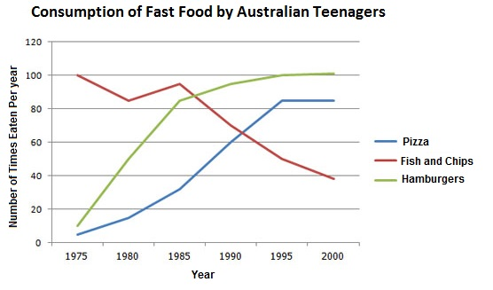

**Introduction:** Paraphrase the question. It is best to paraphrase the question in the first paragraph. You can do this by using synonyms. This is simply what you are going to do in your introduction. You should try to add information regarding type of the graph, title of the graph, scale of the graph and period of the graph.

Introduction 1: The assigned line graph illustrates the changes in the quantity and variety of fast food eaten by Australian teenagers between 1975 and 2000.

Introduction 2: The line chart depicts Australian teenagers' consumption of three different types of fast food from 1975 to 2000.

**Overview:** (Choose 2-4 most significant features you observe and write them in general terms. Main features are highest/lowest, increasing/decreasing trend, constant trend, overall significant difference or similarities, Volatile or fluctuation situation, or any significant exceptions. Don’t write the figures of the scale in this portion)

Overview 1: Overall, it can be seen from the graph that the consumption of fish and chips gradually decreased, while the popularity of both hamburgers and pizza rose dramatically among Australian teenagers.

Overview 2: A general overview of the data shows that initially fish and chips were the most popular but gradually declined over time. In contrast, both hamburgers and pizza grew significantly in popularity, with hamburgers becoming the top choice by the end of the period.

Overview 3: As can be seen, Australian teenagers preferred fish and chips in 1975, but by 2000, hamburgers and pizza had surpassed it in popularity.

**Body:** (Support the main features. In a new paragraph, support the key features with the data in the information given to you.)

Body 1: The graph illustrates that the consumption of fish and chips touched its highest point in 1975 with nearly 100 times per year and maintained its dominance until the 1980s. Despite minor fluctuations, the trend showed a clear downward pattern, with consumption falling to around 40 times per year by 2000. This decline reveals a significant drop in popularity among teenagers over the 25 year period.

OR

According to the graph, fish and chips were eaten 100 times a year in 1975. There was a slight variation in consumption up until 1985. After 1985, consumption declined sharply, falling to under 40 times a year by 2000.

Body 2: Conversely, the intake of pizza and hamburgers in 1975 was markedly lower, with both being eaten about 15 times per year. Over the following 25 years, hamburgers gained popularity, surpassing fish and chips by the 1980s and reaching around 100 times annually. Pizza also increased in popularity, reaching about 85 times annually from 1995 to 2000.

Complete Task:

The assigned line graph illustrates the changes in the quantity and variety of fast food eaten by Australian teenagers between 1975 and 2000.

A general overview of the data shows that initially fish and chips were the most popular but gradually declined over time. In contrast, both hamburgers and pizza grew significantly in popularity, with hamburgers becoming the top choice by the end of the period.

The graph illustrates that the consumption of fish and chips touched its highest point in 1975 with nearly 100 times per year and maintained its dominance until the 1980s. Despite minor fluctuations, the trend showed a clear downward pattern, with consumption falling to around 40 times per year by 2000. This decline reveals a significant drop in popularity among teenagers over the 25 year period.

Conversely, the intake of pizza and hamburgers in 1975 was markedly lower, with both being eaten about 15 times per year. Over the following 25 years, hamburgers gained popularity, surpassing fish and chips by the 1980s and reaching around 100 times annually. Pizza also increased in popularity, reaching about 85 times annually from 1995 to 2000.